Sire Inspection Module
A Quick Guide

1. Sire Inspection Reports

These reports will display the data related to the Sire Audit. There are 13 reports in this module divided into 4 sections.
To Navigate to this module login into BI instance using the below url.
http://192.168.166.203:9704/analytics/saw.dll?bieehome&startPage=1

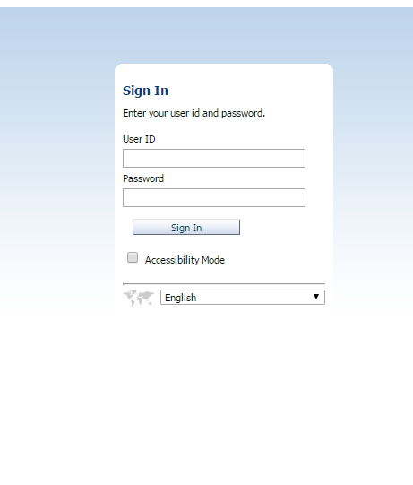

Enter the below Credentials
User ID : Operations
Password : welcome1

Once Logged in then navigate to the dashboards and select Sire Inspection Dashboard

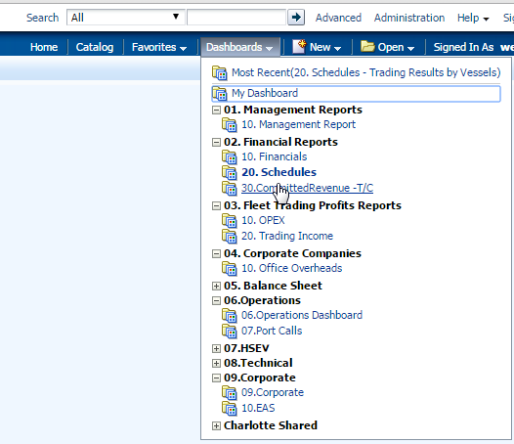

- Once logged in then click on the URL to navigate to the required report.
    - There are 2 dashboards under this module
        - Contracts Graph
        - Contracts Details

- Contracts Graph displays the revenue for the contracts with in 1 year, 2 to 5 years and greater than 5 years in bar chart
The parameters for this dashboard are
Vessel Code(Optional)
Vessel Name( Optional)
Fleet(Optional)
Reporting Date (Mandatory)

This dashboard displays the CommittedRevenue in form of bar graph based on the selection criteria
End Date > Reporting date i.e. for 31 Dec 2015 financials, End date 01 Jan 2016 and onwards, CP Date <= Reporting Date, i.e. for 31 Dec 2015 financials, Cp Date upto 31 Dec 2015

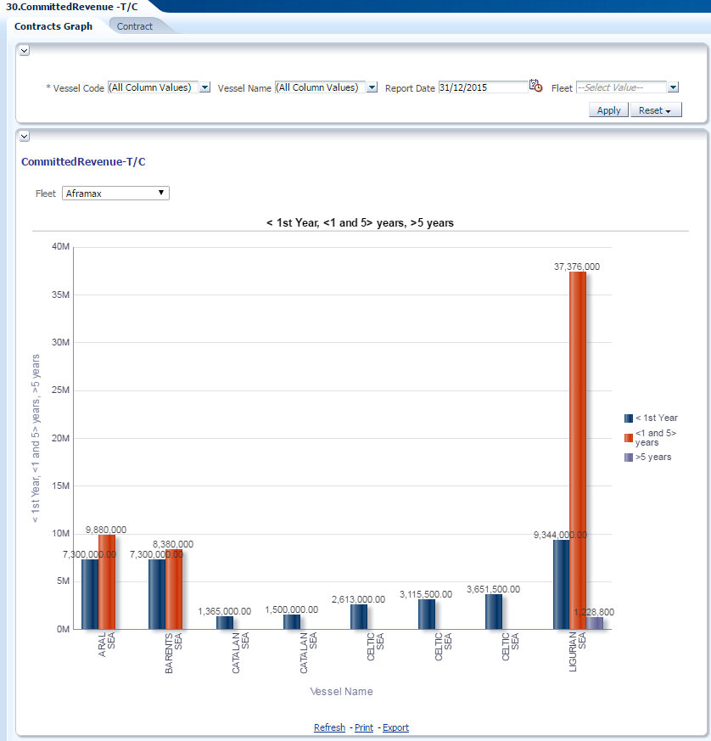

- Contracts displays the revenue for the contracts with in 1 year, 2 to 5 years and greater than 5 years
The parameters for this dashboard are
Vessel Code(Optional)
Vessel Name( Optional)
Fleet(Optional)
Reporting Date (Mandatory)

This dashboard displays the CommittedRevenue in form of bar graph based on the selection criteria
End Date > Reporting date i.e. for 31 Dec 2015 financials, End date 01 Jan 2016 and onwards, CP Date <= Reporting Date, i.e. for 31 Dec 2015 financials, Cp Date upto 31 Dec 2015

